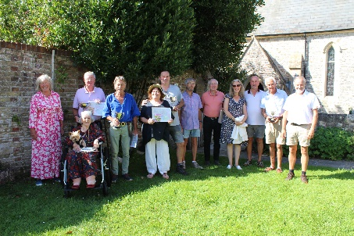

**Please check noticeboards for agendas & changes to timings and dates.**

**Reflections on 2023**

**Throughout the year the community has enjoyed a full programme of events.**

**There was the King’s Coronation with various events and the village wide volunteer litter**

**pick. Thank you to everyone who took part.**

**Excitement was high amongst our younger members with the arrival of the new swings in**

**Steyne Park. The PC were very pleased to finally get them installed.**

**Back in June the PC organised the annual**

**Bembridge in Bloom competition. Our thanks to everyone who took rt and congratulations to all the winners.**

**The 2023 Star Competition is about to be judged. It is open to everyone; decorate your houses and gardens, include a star and the judges will pick a winner whilst wandering around the village between 14th and 18th December 2023.**

**There was a very enjoyable evening back in September when the Parish Council organised their annual Community Chest event. This event enables village groups to apply to the Council for a small grant to assist them to purchase items to help their society to fulfil its wishes.**

**The Council hope everyone has had the chance to view the new**

**wildlife boards down by the beach. Thank you to all the**

**Sustainability group who helped make this happen.**

**Beach Cleans: talking about the beach, there have**

**been 9 beach cleans this year. Over 400 kg of rubbish**

**has been collected, but sadly no treasure. Beach**

**cleans will be back next year starting in February. Meet at either The Point or Lane End at 10am. The finish is always at The Point for coffee curtesy of the Harbour View Café. Our thanks to them for warming up all the intrepid beach cleaners after their efforts throughout 2023.**

**Looking to 2024**

**Development – By now we are sure you are all aware of the planning application for 130 houses. The PC are organising an extra planning meeting on Wednesday 3rd January 2024 for villagers to let the PC know their views. Please Note: Your own comments should be on the IoW Council website by 3rd January 2024.**

**Village Defibrillators - We are very lucky to have several of these devices in the village. The PC Office has a map showing where they are situated. Last year 2 free training sessions were organised and the PC hope to organise another in the new year. If you are interested, please contact the office with your details.**

**The Parish Council is keen to gather a list of all clubs and societies in the New Year so that**

**when new residents move in they are able to point them to a group of like-minded people**

**who will open up new friendships and interests. If you run a club or society, please email**

**some contact details to the Parish Office so your club can be included in our directory.**

**It just leaves us to wish you all a very Merry Christmas and Happy New Year.**

**PC Meetings:**

**P&E – 5.00pm Wednesday 20th December 2023 &**

**P&E – 5.30pm Wednesday 3rd January 2024 (Application 23/01920/FUL)**

**Full Council – 7pm Wednesday 20th December 2023**

**F&G – 7pm Wednesday 10th January 2024**