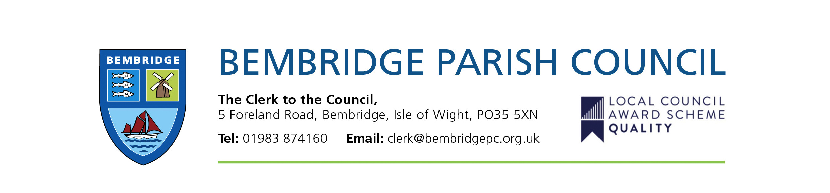

Bembridge Village Hall
Press Release

Following the sale of 5/7 High Street in October 2019 which realised a capital fund of £174,000, the restoration of Bembridge Village Hall was viewed as a priority by Bembridge Parish Council. This was to include a completely new roof and the restoration of the windows and doors which have fallen into serious disrepair. As the Village Hall is situated within Bembridge Conservation area, conditions of the conservation officer had to be adhered to such as replacing tiles on a like for like basis.
Following a tender process and agreement by Bembridge Parish Council in September 2020, work commenced on the replacement roof in November 2020. During the period of works, the Parish Council received many comments about the progress and standard of the work and the very good conduct of the contractors, RTR Roofing, along with the little mess and disruption caused. The work was completed at the end of February to a very high standard. The original budget agreed for the roof work was £59,000 with a £15,000 contingency. £5000 contingency was required to restore some of the fascia’s that were damaged during the removal of the original roof. A separate quote of £15,000 for restoration of the front and side fascias was agreed by the Parish Council in November 2020 and this work was completed alongside the roof work in February 2021, again to a very high standard by CJB Renovations. The restoration work on the windows and doors was agreed by the Parish Council in February 2021 and work is expected to commence in March/April 2021.

Before Before
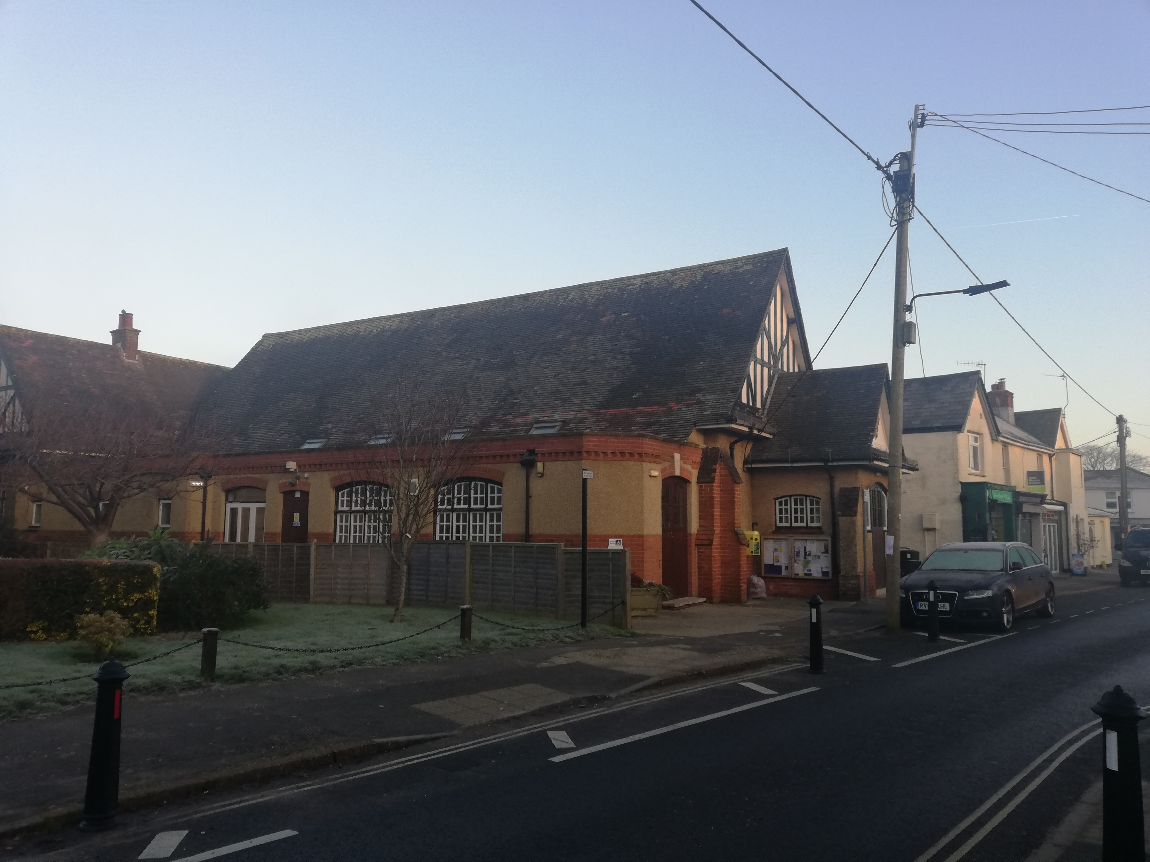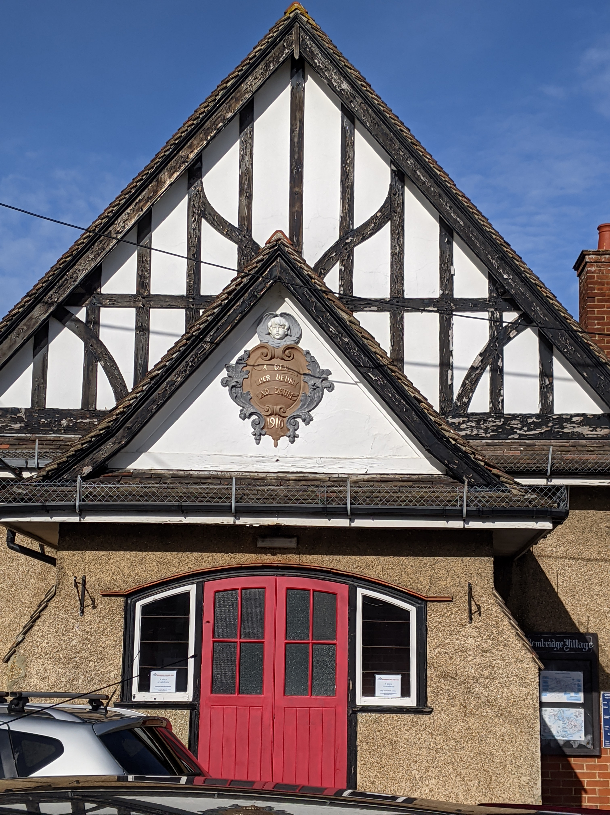

After After
